PHP Exercise 4

<?php

// Multidimenional array

$scores=[['PHP session',2],['PHP session 2',4],

['PHP session 3',6],

['PHP session 4',1],['PHP session 5',2]];

array_unshift($scores,['PHP session8',8],

['PHP session9',4],['PHP session10',5]);

echo '<pre>';

print_r($scores);

echo '</pre>';

echo '<br>';

$permissions = [

    'edit',

    'delete',

    'view'

];

$colors = [

    'red' => '#ff000',

    'green' => '#00ff00',

    'blue' => '#0000ff',

];

// use of an array_unshift functions

array_unshift($permissions, 'cancel','approve'

,'valid','hide');

$numbers = [1, 2, 3];

echo '<pre>';

print_r($permissions);

echo '</pre>';

$colors = ['black' => '#000000'] + $colors;

echo '<pre>';

print_r($colors);

echo '</pre>';

array_push($numbers, 4, 5);

echo '<pre>';

print_r($numbers);

echo '</pre>';

?>

Array

(

[0] => Array

(

[0] => PHP session8

[1] => 8

)

[1] => Array

(

[0] => PHP session9

[1] => 4

)

[2] => Array

(

[0] => PHP session10

[1] => 5

)

[3] => Array

(

[0] => PHP session

[1] => 2

)

[4] => Array

(

[0] => PHP session 2

[1] => 4

)

[5] => Array

(

[0] => PHP session 3

[1] => 6

)

[6] => Array

(

[0] => PHP session 4

[1] => 1

)

[7] => Array

(

[0] => PHP session 5

[1] => 2

)

)

Array

(

[0] => cancel

[1] => approve

[2] => valid

[3] => hide

[4] => edit

[5] => delete

[6] => view

)

Array

(

[black] => #000000

[red] => #ff000

[green] => #00ff00

[blue] => #0000ff

)

Array

(

[0] => 1

[1] => 2

[2] => 3

[3] => 4

[4] => 5

)

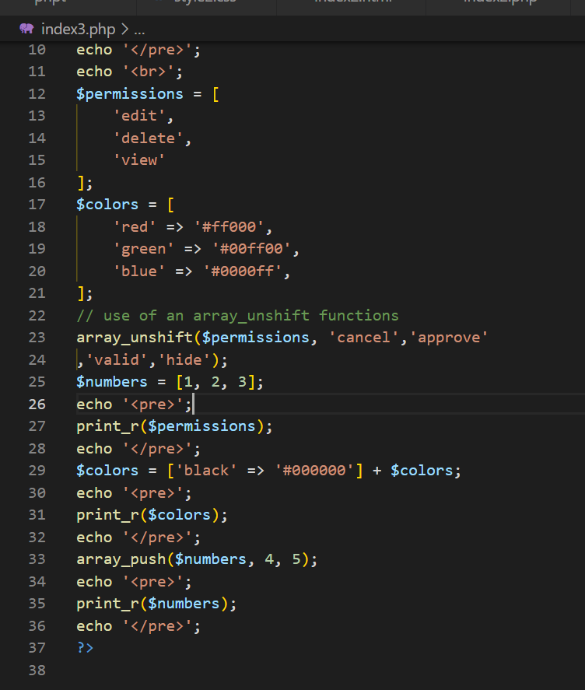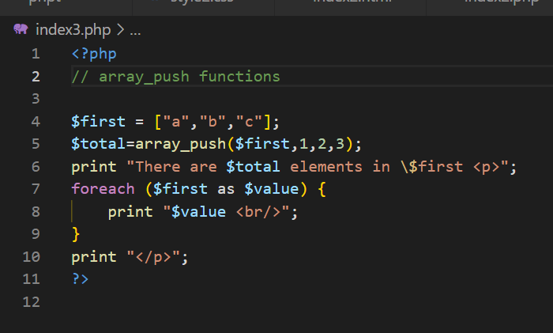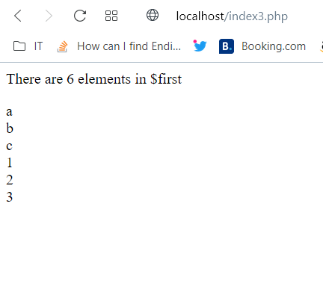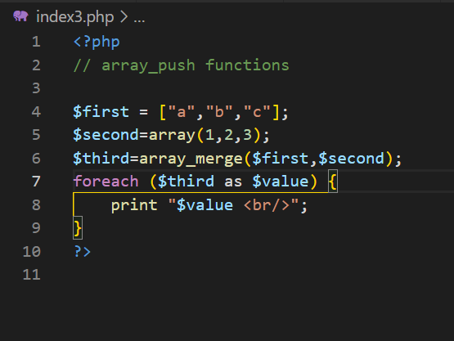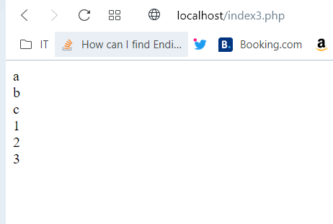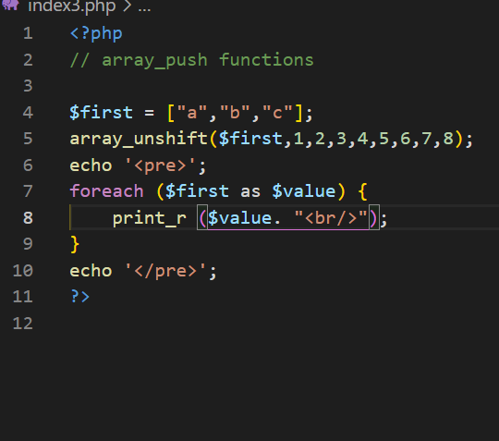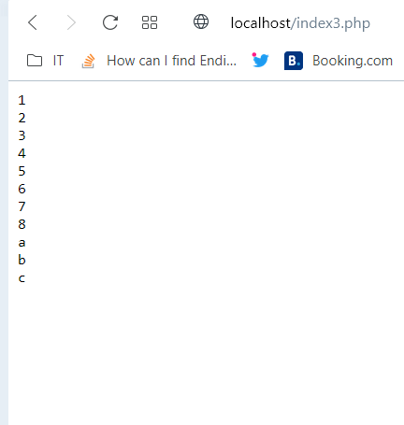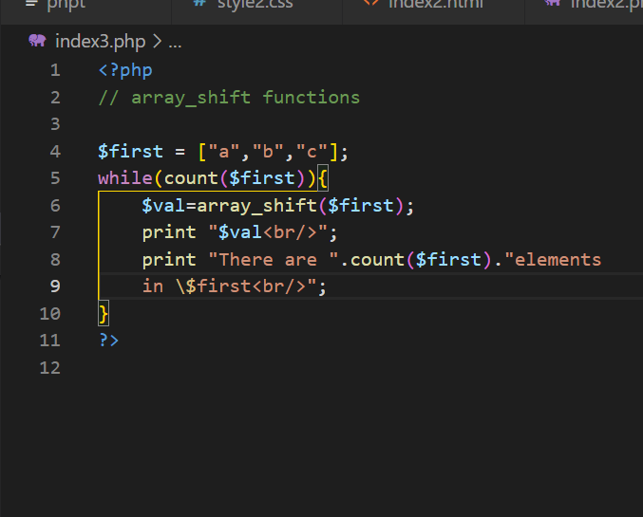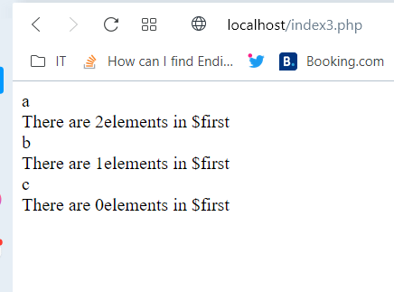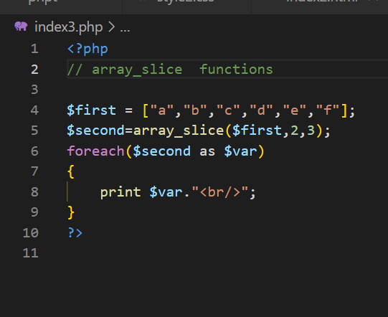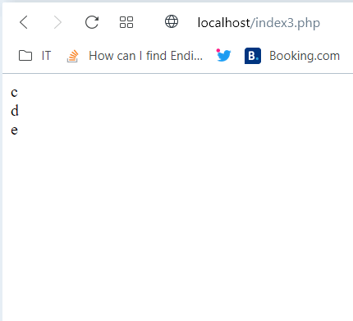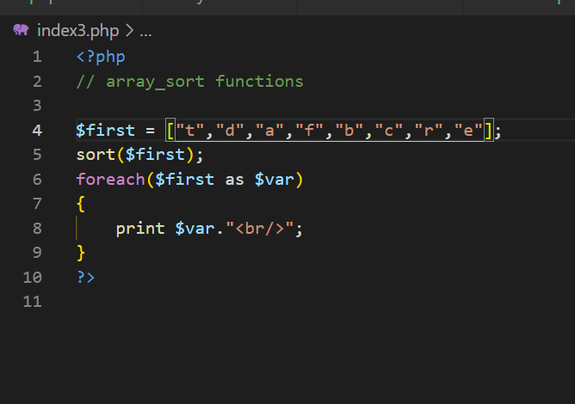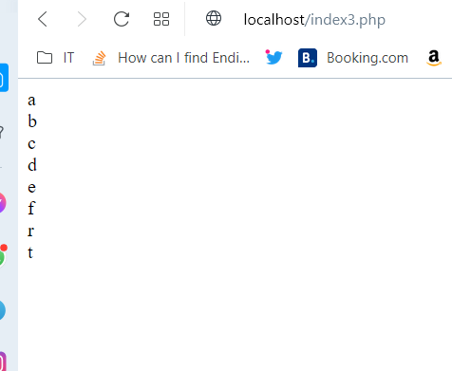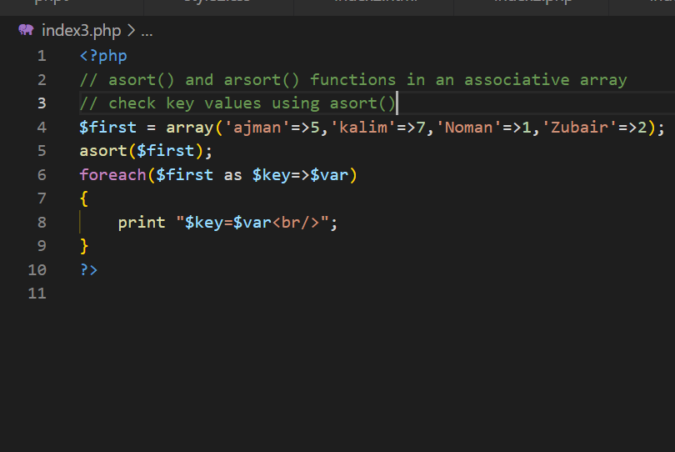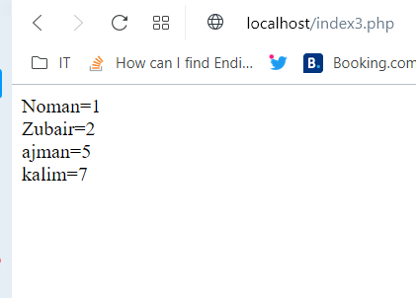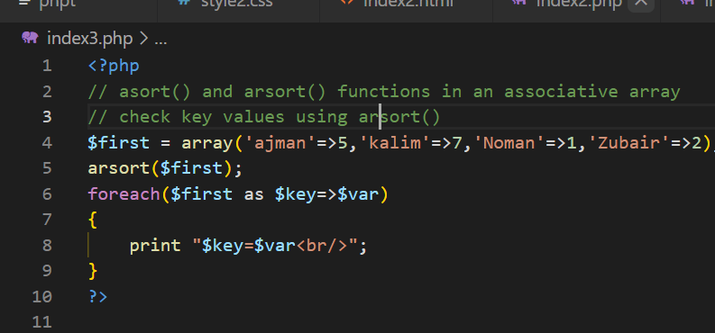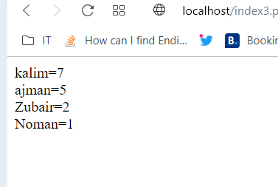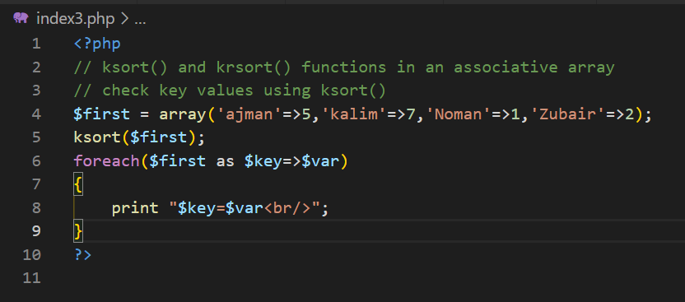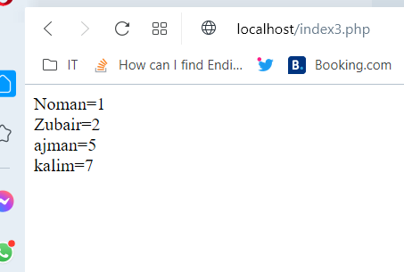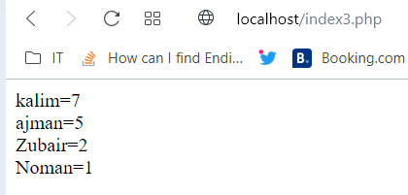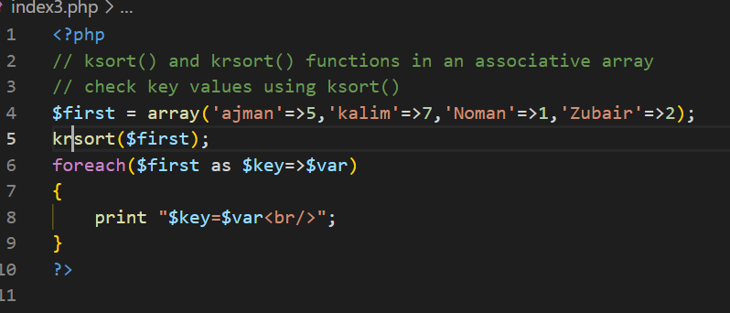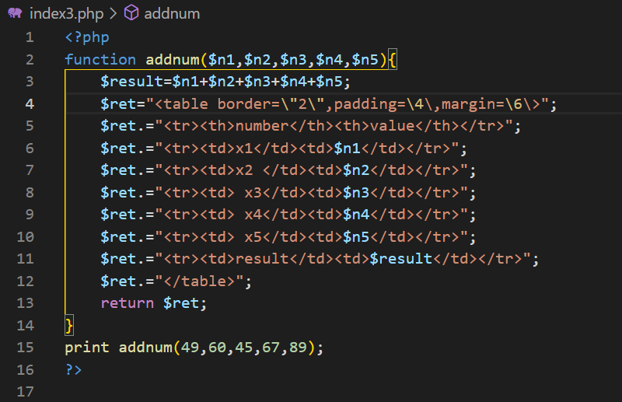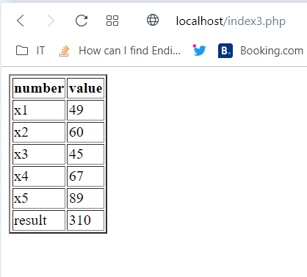

<?php

function addnum($n1,$n2,$n3,$n4,$n5){

    $result=$n1+$n2+$n3+$n4+$n5;

    $ret="<table border=\"2\"";

    $ret.="<tr><th>number</th><th>value</th></tr>";

    $ret.="<tr><td>x1</td><td>$n1</td></tr>";

    $ret.="<tr><td>x2 </td><td>$n2</td></tr>";

    $ret.="<tr><td> x3</td><td>$n3</td></tr>";

    $ret.="<tr><td> x4</td><td>$n4</td></tr>";

    $ret.="<tr><td> x5</td><td>$n5</td></tr>";

    $ret.="<tr><td>result</td><td>$result</td></tr>";

    $ret.="</table>";

    return $ret;

}

print addnum(49,60,45,67,89);

?>

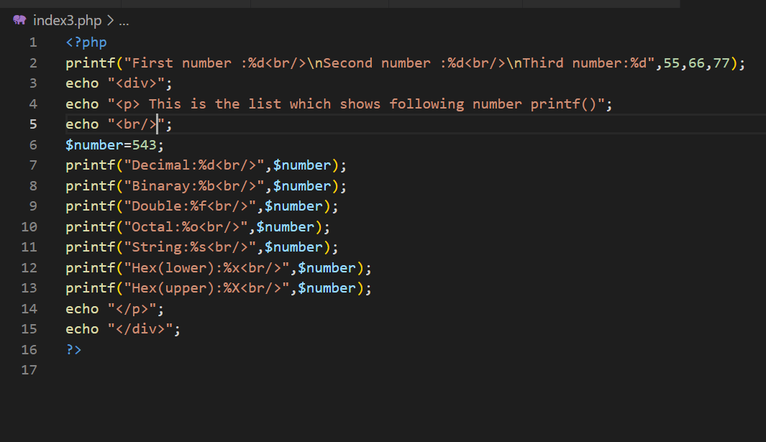

<?php

printf("First number :%d<br/>\nSecond number :%d<br/>\nThird number:%d",55,66,77);

echo "<div>";

echo "<p> This is the list which shows following number printf()";

echo "<br/>";

$number=543;

printf("Decimal:%d<br/>",$number);

printf("Binaray:%b<br/>",$number);

printf("Double:%f<br/>",$number);

printf("Octal:%o<br/>",$number);

printf("String:%s<br/>",$number);

printf("Hex(lower):%x<br/>",$number);

printf("Hex(upper):%X<br/>",$number);

echo "</p>";

echo "</div>";

?>

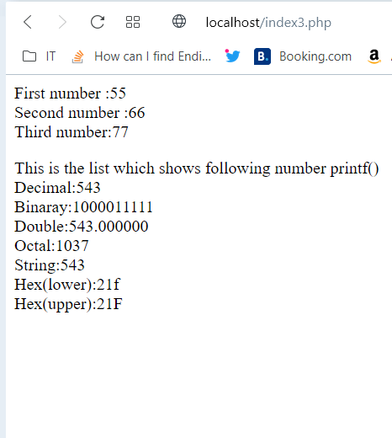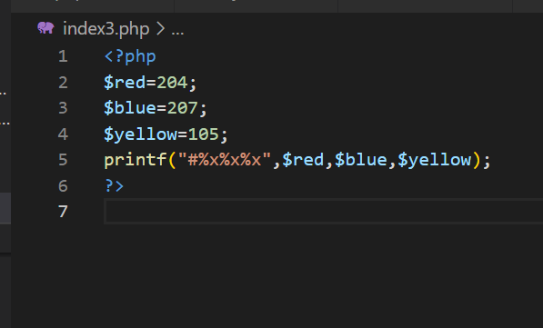s

